**CHAPTER 1**

## **INTRODUCTION**

### **1.1 Introduction to Project**

Accurate identification of skin problems and knowing which natural remedies to use can be difficult, especially in rural areas or when using traditional medicine. Usually, people rely on visiting a doctor or matching symptoms themselves, which can sometimes lead to wrong guesses and treatments that don’t work. Even though many plants are known to help with skin issues, most people don’t have an easy way to find the right plant or learn how to use it properly for their skin.

HerbalLink is an intelligent machine learning-powered web application that assists users in detecting common skin diseases and recommends suitable medicinal leaves as treatment options. Unlike existing solutions that rely on user descriptions or predefined medical databases, HerbalLink uses real-time image classification and user input to deliver personalized, nature-based healthcare guidance. Through HerbalLink, Users can register, upload images of affected skin areas, or scan leaves to receive tailored disease identification, natural remedy suggestions, and detailed usage instructions.

The backend, developed using Flask and Python, leverages machine learning models trained on skin disease and leaf datasets. Image processing is handled using OpenCV, while classification tasks utilize CNN (Convolutional Neural Network) models built with TensorFlow. For the skin module, the system predicts conditions like acne, eczema, or fungal infections based on image features, along with preparation and application guidance sourced from a database. For the leaf module, the system identifies the scanned leaf and retrieves a list of skin diseases it can treat.

HerbalLink offers a new and complete way to care for skin by combining traditional herbal treatments with modern AI technology. It helps people rely less on chemical medicines and gives them easy, natural options for treating skin problems. With just a few steps, users can get useful advice, making skin care more accessible and convenient. By using real-time image analysis and machine learning, HerbalLink not only improves the accuracy of skin condition detection but also ensures that users receive personalized herbal remedies based on their specific needs.

### **1.2 Introduction to Technology**

HerbalLink is a smart healthcare web application that integrates traditional medicinal leaf knowledge with modern technology. In skin mode, it identifies the skin disease and recommends the appropriate medicinal leaf along with Ayurvedic remedy for healing. In leaf mode, it detects the medicinal leaf and displays the list of skin diseases that can be treated using that leaf, helping users understand its medicinal value and uses.

**1.2.1 Python with Flask**

Python with Flask serves as the core backend framework in the HerbalLink web application. Python’s simplicity and rich ecosystem make it ideal for machine learning and web development tasks. Flask, a lightweight and modular web framework in Python, enables the creation of RESTful APIs that connect the web app to the backend logic and machine learning models. The backend receives images and user inputs from the frontend, processes them using Python scripts and CNN models, and sends back the predictions and medicinal leaf recommendations. This architecture ensures a fast and responsive interaction between the user and the system while maintaining flexibility and scalability for future enhancements.

**1.2.2 MongoDB**

MongoDB is a NoSQL database used in HerbalLink to store user information, scan history, and mapping data between diseases and medicinal leaves. The document-based architecture allows the system to store flexible data structures, including JSON-like documents, which is particularly useful for applications that need to evolve and scale quickly.

**1.2.3 Convolutional Neural Networks (CNN)**

CNNs are the core technology behind the image classification feature of HerbalLink. They enable the automatic detection of skin diseases and identification of medicinal leaves from scanned images. CNNs are composed of three main layers:

* **Convolution Layers**: These layers consist of several filters that scan across the input image to detect features such as edges, textures, and patterns. Each filter performs a 2D convolution operation on the image and produces a feature map. These filters act like neurons and learn to identify different features through training.
* **ReLU Layers**: ReLU (Rectified Linear Unit) layers apply an activation function to introduce non-linearity into the model. The function is defined as f(x) = x when x >= 0, and f(x) = 0 when x < 0. It helps the model to learn complex patterns by allowing only positive values to pass through.
* **Pooling Layers**: Pooling layers are used to reduce the dimensions of the feature maps. Max pooling is the most common type, where the highest value in a group of pixels is retained, and the rest are discarded. This reduces computational load and helps extract the most important features.

**1.2.5 TensorFlow**

TensorFlow is an open-source deep learning framework developed by Google. It is used to build, train, and deploy the CNN models used in HerbalLink. TensorFlow supports both CPU and GPU computation, making it suitable for running complex models efficiently. It is also integrated with tools like Keras to simplify the design of neural networks.

**1.2.6 OpenCV**

OpenCV (Open Source Computer Vision Library) is a library of programming functions mainly aimed at real-time computer vision. It is used in HerbalLink for preprocessing images, such as resizing, background removal, and noise reduction. This improves the quality of the input data for better prediction by the CNN model.

**CHAPTER 2**

**LITERATURE SURVEY**

### **2.1 Introduction**

A literature review offers a detailed overview of previously conducted research related to a specific topic. It evaluates scholarly books, journal articles, and other academic sources to understand the current knowledge and identify research gaps.

### **2.2 Literature Survey**

Tabassum and Hamdani [1] explored the traditional use of medicinal plants in Norway for treating skin diseases and cosmetic applications. The study documents a variety of native plants known for their dermatological benefits, such as anti-inflammatory, antimicrobial, and wound-healing properties. It highlights key species like Aloe vera, Calendula officinalis, and Hypericum perforatum, emphasizing their active phytochemicals and therapeutic effects. The paper discusses preparation methods and cultural significance, linking ethnobotanical knowledge with modern pharmacological findings. This research underscores the value of integrating traditional plant-based remedies with contemporary skin disease treatment strategies and promotes further investigation into their efficiency and safety.

Hicham Bouakkaz et al. [2] presented a study on enhanced classification of medicinal plants using deep learning and optimized Convolutional Neural Network (CNN) architectures. The authors addresses key challenges in plant classification such as inter-class similarity and intra-class variation by proposing a refined CNN-based approach tailored for plant leaf imagery. The research emphasizes the optimization of CNN architectures through hyperparameter tuning and regularization techniques to boost classification performance. They also evaluated their model using publicly available datasets, achieving superior accuracy compared to conventional methods. The study highlights the effectiveness of deep learning in automated botanical classification and its potential application in pharmacognosy, biodiversity preservation, and herbal medicine research. This work contributes to the growing field of AIassisted plant identification, setting a benchmark for future exploration in medicinal plant informatics.

A. Rajasekar et al. [3] developed an AI-based Skin Disease Detector integrating convolutional neural networks (CNN) and YOLOv8 for automated skin condition classification. The system processes both images and video frames through a series of preprocessing techniques such as contrast enhancement, segmentation, and hair removal to enhance lesion visibility and accuracy. Trained on a large dataset including the ISIC archive, the model achieved high performance metrics, including 90% accuracy and 0.85 AUC-ROC, demonstrating its diagnostic reliability. YOLOv8 enabled real-time lesion localization with 53 convolutional layers. Additionally, the system incorporates stress and fatigue analysis using physiological data. A robust user interface was also implemented to ensure accessibility and usability in varied lighting and clinical conditions. This approach supports efficient and accurate skin disease detection in both clinical and remote healthcare settings.

Rajasekar A., Shouvik C., and Mariya H. [4] proposed a multiattribute deep convolutional neural network (CNN) approach for accurately detecting medicinal plants and identifying their applications in treating skin diseases. The study integrates multiple attributes such as texture, color, and shape in the CNN architecture to enhance classification accuracy. Additionally, the paper explores the therapeutic relevance of detected plants by linking them to specific skin disease treatments, contributing to both automated plant recognition and practical medicinal use. The proposed method demonstrates improved performance compared to traditional techniques and highlights the potential of deep learning in botanical and medical informatics. This work sets a foundation for further research on AI-driven plant-based healthcare solutions.

Kale et al. [5] investigated the identification of Ayurvedic medicinal leaves and the recommendation of home remedies using state-of-the-art deep learning algorithms and a comprehensive dataset. The study introduces an Android-based application designed to classify 115 distinct species of medicinal leaves from a dataset of 6,541 images. The system employs well-known pre-trained neural networks including CNN, VGG16, MobileNet, and Inception to accurately identify leaves. In addition to leaf classification, the research addresses disease identification through a symptom-disease dataset encompassing 35 symptoms and 20 diseases. The conventional train-test split method ensures reliable model evaluation, preventing overfitting. The study emphasizes the integration of leaf image recognition with symptombased Ayurvedic medicine and home remedy recommendations. Comprehensive performance metrics including accuracy, precision, recall, F1-score, and confusion matrices are utilized to assess the model's effectiveness. This work contributes significantly to bridging traditional Ayurvedic knowledge with modern AI techniques, enabling automated medicinal leaf identification and personalized treatment suggestions.

Andrew Al C. Aquiro et al. [6] developed a device that can recognize and identify herbal medicine plants by looking at their leaves. They used a powerful image recognition model called ResNet50, which is a type of deep learning algorithm. Instead of training the model from scratch, they used a method called transfer learning, which helps the model learn faster and more accurately by using knowledge from other similar tasks. Their system includes both hardware and software, so it can identify plants in real time using a camera and computer. This device is useful for healthcare and plant research, as it helps people easily recognize medicinal plants. Overall, the study shows how artificial intelligence can be used in traditional medicine and plant science.

Rajasekaran Subramanian [7] developed a mobile application designed to identify Ayurvedic medicinal leaves and retrieve their associated therapeutic properties using deep learning and natural language processing (NLP) techniques. The system employs a convolutional neural network (CNN) to classify leaf images captured via a smartphone camera. Subsequently, NLP methods are utilized to extract relevant medicinal information from a curated textual database. The integration of these technologies facilitates real-time, userfriendly access to Ayurvedic knowledge, aiming to bridge the gap between traditional medicine and modern technology. The paper reports high accuracy in leaf classification and effective retrieval of medicinal properties, highlighting the potential of AI-driven tools in promoting the accessibility and preservation of traditional medicinal practices.

Praveen Kumar Sekharamantry [8] proposed PSR-LeafNet, a novel deep learning framework designed for identifying medicinal plant leaves by integrating a three-stage network—P-Net, S-Net, and R-Net—for feature extraction. The model uses Support Vector Machines (SVM) for final classification to enhance accuracy and robustness. It was tested on multiple datasets, including Flavia, MalayaKew, and the Indian Medicinal Plant dataset, achieving high classification accuracy. This study demonstrates the potential of hybrid deep learning and machine learning approaches in medicinal plant identification, offering a scalable and efficient solution for botanical research and healthcare applications.

Smith et al. [9] investigated the identification of traditional medicinal plant leaves using an effective deep learning model and a self-curated dataset. They introduced a customized convolutional neural network (CNN) designed to accurately extract features from leaf images. To overcome limitations of existing datasets, the study compiles a diverse self-curated dataset representing various traditional medicinal plants. The research emphasizes the importance of high-quality and diverse data in improving classification accuracy. Advanced image preprocessing techniques are also applied to enhance leaf segmentation and clarity. The paper highlights the significance of combining domain-specific datasets with tailored deep learning architectures for reliable plant identification. This work lays the foundation for further AIbased advancements in botanical classification and traditional medicine.

Rakib et al. [10] proposed an automatic recognition system for medicinal plants based on multispectral and texture features using a hidden deep learning model. The research focuses on leaf-based identification, collecting images from five different medicinal plant species in natural environments. The study applies Convolutional Neural Networks (CNNs), particularly the VGG16 architecture, achieving a classification accuracy of 95.48%. The model leverages both multispectral and texture features to improve robustness and precision in plant identification. Image preprocessing plays a vital role in enhancing classification performance. The system aims to facilitate the medical sector by enabling accurate, automated recognition of medicinal plants, which can assist in medicinal plant awareness and preservation. Evaluation metrics include accuracy and model reliability through deep learning algorithms, contributing to the integration of AI with botanical research.

Pradnya Patil et al. [11] proposed a computer vision-based system designed for accurate identification of medicinal plant leaves. The authors utilized deep learning techniques, particularly convolutional neural networks (CNNs), to extract and analyze leaf features such as shape, texture, and venation patterns. The study emphasizes the integration of image preprocessing methods to enhance feature clarity and model robustness. Experimental results demonstrate high accuracy in classifying multiple medicinal plant species, addressing challenges related to intra-class variability and inter-class similarity. The paper discusses the practical application of the system in aiding herbal medicine identification and promoting traditional knowledge preservation. This work contributes to the development of automated tools for botanical research and healthcare.

Nidhi Tiwari et al. [12] explored the application of deep learning and traditional machine learning algorithms for the classification and identification of medicinal plant leaves using their spectral characteristics. The study emphasizes the use of hyperspectral imaging data, which captures detailed spectral signatures unique to different plant species, enabling more precise identification. They compare various machine learning classifiers such as Support Vector Machines (SVM), Random Forest (RF), and deep learning models like Convolutional Neural Networks (CNN) to assess their effectiveness in distinguishing between similar plant species. The paper also discusses preprocessing techniques and feature extraction methods to enhance model performance. Their findings demonstrate that deep learning models, particularly CNNs, outperform conventional classifiers in accuracy and robustness. This research highlights the potential of integrating spectral data with advanced learning algorithms for reliable medicinal plant identification, contributing to biodiversity conservation and the pharmaceutical industry. The work sets a foundation for future advancements in automated plant recognition systems using spectral imaging.

Sheetal S. Patil et al. [13] investigated the application of Convolutional Neural Networks (CNNs) for the identification of medicinal plants. They utilized a dataset comprising 1,500 leaf images from various medicinal plant species to train and validate their model. The study demonstrates that CNNs can effectively extract features from raw image data, leading to an impressive classification accuracy of 99.10%. This research highlights the potential of deep learning techniques in automating the identification process of medicinal plants, which is traditionally reliant on expert knowledge and manual observation. The findings underscore the efficacy of CNNs in handling complex image data for plant classification tasks.

Azadnia et al. [14] proposed an AI-based approach for medicinal plant identification using a deep Convolutional Neural Network (CNN) architecture enhanced with Global Average Pooling (GAP). The study focuses on the classification of five medicinal plant species by analyzing leaf images. The CNN model comprises a feature extraction block and a classifier block, which includes a GAP layer, a dense layer, a dropout layer, and a softmax layer. The model was tested on images resized to 64×64, 128×128, and 256×256 pixels, achieving over 99.3% accuracy across all resolutions. This approach demonstrates the potential of deep learning techniques in accurately identifying medicinal plants, offering a viable alternative to traditional, time-consuming identification methods.

Amey Sunil Deshmukh et al. [15] presented a study on Ayurvedic plant identification leveraging image processing and artificial intelligence techniques. The paper focuses on developing an automated system capable of accurately identifying medicinal plants used in Ayurveda by analyzing leaf images. The authors employ preprocessing methods, feature extraction techniques, and classification algorithms to enhance identification accuracy. Their approach aims to assist practitioners and researchers by providing a reliable tool to recognize plants without extensive botanical expertise. The study emphasizes the importance of AIdriven solutions in traditional medicine, improving accessibility and preservation of herbal knowledge. This work contributes to the intersection of computer vision and ethnobotany, setting the stage for further advancements in AI-assisted plant recognition systems.

Sukhadia et al. [16] proposed a deep learning-based method for automated skin disease detection using the Fast R-CNN architecture. Their approach addresses limitations in traditional image classification techniques by integrating object detection and classification in a single framework. The system was trained on a custom skin disease dataset, and it demonstrated improved accuracy in detecting and localizing various skin conditions compared to basic CNN models. The Fast R-CNN model efficiently identifies multiple disease regions within dermatological images, even under challenging conditions such as low contrast and overlapping lesions. The authors also developed a user interface to simplify disease identification for non-expert users. Their results highlight the effectiveness of Fast R-CNN in medical image analysis, providing a foundation for real-time skin disease screening tools.

Esmaieeli Sikaroudi, A. Mohammad et al. [17] proposed a deep learning-based method for the automated detection of skin diseases using Fast R-CNN, a region-based convolutional neural network. Their approach leverages a dataset of labeled skin lesions to train a model that can accurately identify various types of skin diseases. The Fast R-CNN model outperforms traditional machine learning methods, achieving high accuracy in detecting skin abnormalities. The authors also implemented a preprocessing step to enhance the quality of skin images, improving detection performance under varying conditions. Experimental results showed a significant reduction in false positives compared to other existing techniques. The study's findings suggest that this deep learning-based approach has great potential in clinical practice for assisting dermatologists with skin disease diagnosis. A user-friendly interface was also developed to facilitate ease of use for medical practitioners.

Miss Mukta Kamble et al. [18] proposed a dual-stage skin disease detection system combining image processing and machine learning. The authors designed a mobile-based application that utilizes computer vision techniques for image preprocessing and feature extraction, followed by a convolutional neural network (CNN) for classification. They categorized the detection process into two phases—image preprocessing and disease classification—and emphasize the system’s applicability in rural and resource-limited settings. The study reports an accuracy of up to 95% for detecting diseases like Psoriasis, Lichen Planus, and Pityriasis Rosea. Challenges such as varying skin tones and image quality are identified, with future work focusing on improving robustness and expanding disease coverage. This work highlights the potential of integrating clinically evaluated histopathological features with machine learning models for accessible and reliable dermatological diagnosis.

Alaa Haddad and Shihab A. Hameed [19] proposed a framework for automated skin disease detection using image processing and machine learning techniques. The system focuses on identifying multiple skin conditions—acne, psoriasis, melanoma, and heat rash—from mobile-acquired images. The methodology involves a sequence of preprocessing (using Gaussian and median filters), color space conversion (RGB to YCbCr), and segmentation (via K-means Fuzzy C-means clustering) to isolate the skin region. Key features—both color and texture-based—are extracted and classified using a Support Vector Machine (SVM) with a radial basis function kernel. The proposed system achieved a classification accuracy of 90.09% with KNN and 82.5% with MSIM. A mobile interface was developed to capture images in real-time and initiate diagnosis, improving accessibility and user experience. This multidisease detection approach offers significant advancement over prior models that focused on single diseases, enabling faster and more accurate dermatological assessments.

Nahida Tabassum and Mariya Hamdani [20] explored the use of medicinal plants in the treatment of skin diseases by documenting 31 species traditionally employed in herbal remedies. The study emphasizes plant-based treatments for conditions such as eczema, acne, psoriasis, and skin infections. It presents Aloe vera, Allium cepa, Azadirachta indica, Curcuma longa, and Ocimum sanctum as key examples with antibacterial, antifungal, and anti inflammatory properties. The authors highlights the pharmacological potential of these plants and advocate for scientific validation and clinical trials. This work contributes to the growing interest in herbal dermatology and supports the development of plant-based therapeutic solutions.

### **2.3 Summary of Literature Survey**

The literature review highlights the use of deep learning, especially CNNs, for accurate skin disease detection and medicinal plant identification. Several studies also emphasize the integration of web applications and traditional herbal knowledge for practical use. HerbalLink builds on these advancements by combining AI-based diagnosis with plant recognition to recommend natural remedies for skin diseases. Table 2.1 shows the summary of literature survey carried out.

**Table 2.1: Summary of Literature Survey**

|  |  |  |  |  |
| --- | --- | --- | --- | --- |
| **Author Name** | **Title of Paper** | **Methodology used** | **Advantages** | **Future Work** |
| Nahida Tabassum and Mariya Hamdani | Plants used to treat skin diseases | Reviewed 31 medicinal plants and their traditional uses for skin diseases. | Connects traditional and modern medicine highlights useful plants. | Test plants scientifically create standard herbal products. |
| Hicham Bouakkaz, Rania Kessab, Samira Bendoukha, and Abderrazak Ouldali | Enhanced Classification of Medicinal Plants Using Deep Learning and Optimized CNN Architectures | Used optimized CNN for better plant image classification. | High accuracy easy to use supports herbal medicine research. | Add more plant images; develop mobile apps; use transfer learning. |
| A. Rajasekar et al. | AI-Based Skin Disease Detector Using CNN and YOLOv8 for Image and Video-Based Diagnosis | Combined CNN and YOLOv8 for detecting and classifying skin diseases. | Real-time detection; 90% accuracy reliable results. | Add more disease types; use cloud for telemedicine. |
| Rajasekar A., Shouvik C., and Mariya H. | Multiattribute Deep CNN for Medicinal Plant Detection and Therapeutic Application in Skin Disease Treatment | Used multi-feature CNN (color, shape, texture) for plant detection. | Accurate and reliable plant recognition. | Add more species and diseases; build mobile app. |
| Kale et al. | Automated Identification of Ayurvedic Medicinal Leaves and Home Remedy Recommendation | Used CNN, VGG16, and MobileNet on leaf dataset for recognition. | Accurate plant ID gives home remedies; easy to use. | Improve speed; expand dataset; use feedback for updates. |
| Andrew Al C. Aquiro, Shannen L. Arreola, and Ramon G. Garcia | Herbal Medicine Plant Leaf Identification Device Using ResNet50 | Used ResNet50 with transfer learning for real-time leaf detection. | Fast and accurate supports traditional medicine. | Add more plant data; improve device portability. |
| Rajasekaran Subramanian | AI-Based Mobile Application for Identification of Ayurvedic Medicinal Leaves and Retrieval of Therapeutic Properties | Used deep learning and NLP in a mobile app for plant ID and info. | Real-time detection gives detailed plant benefits. | Add more plants; improve language support; add AR features. |
| Praveen Kumar Sekharamantry | PSR-LeafNet: A Hybrid Deep Learning Framework for Medicinal Plant Leaf Identification | Combined multiple networks(P-Net, S-Net, R-Net) with SVM. | Strong accuracy works well for research use. | Cover more species; make model work in real time. |
| Smith et al. | Identification of Traditional Medicinal Plant Leaves Using Customized Deep Learning Models | Used custom CNN for plant image classification. | High accuracy adaptable to specific datasets. | Add more data; integrate into real applications. |
| Rakib et al. | Automatic Recognition of Medicinal Plants Using Multispectral and Texture Features with Deep Learning | Used multispectral imaging and texture analysis for leaf ID. | Very accurate (95.48%) works in natural conditions. | Add more species; test under varied environments. |
| Pradnya Patil, Ankita Chavan, Akash Kurane, Pratiksha Nikam, and Prof. R. R. Navghane | FloraMediVision: A Medicinal Plant Leaf Identification System using Computer Vision | Used CNN to identify plants based on leaf features. | High accuracy supports herbal medicine. | Add more plants; improve for mobile devices. |
| Nidhi Tiwari et al. | Applying Deep Learning and Machine Learning Algorithms for The Identification of Medicinal Plant Leaves Based on Their Spectral Characteristics | Used hyperspectral imaging with CNN for classification. | Accurate; handles similar-looking species well. | Make real-time models; support mobile devices. |
| Sheetal S. Patil, Sneha K. Patil, and Rutuja D. Gaikwad | Medicinal Plant Identification Using Convolutional Neural Networks | Used CNN on 1,500 leaf images for classification. | 99.10% accuracy reduces manual work. | Build real-time apps; improve model performance. |
| Azadnia, N., Azadnia, A., and Salimi, H. | Medicinal Plant Identification Using Deep CNN with Global Average Pooling | Used CNN with pooling and dense layers for plant ID. | 99.3% accuracy fast and reliable. | Make mobile version; expand plant list. |
| Amey Sunil Deshmukh, Priyanka Dinkar Rathod, and Prashant Nivrutti Dighe | Medicinal Plant Identification Using Image Processing Techniques | Used image preprocessing and AI-based classification. | Easy, reliable, and useful for Ayurvedic study. | Add more plant images; improve app performance. |
| Sukhadia, H., Patel, K., & Desai, S. | Deep Learning-Based Automated Skin Disease Detection using Fast R-CNN | Used Fast R-CNN for identifying multiple skin diseases. | Accurate and robust; detects overlapping lesions. | Improve for mobile use; add treatment options. |
| Esmaieeli Sikaroudi, A. Mohammad et al. | Deep Learning-Based Automated Detection of Skin Diseases Using Fast R-CNN | Used Fast R-CNN for skin disease detection from images. | High accuracy fewer errors handles image variations. | Add rare diseases; improve segmentation models. |
| Miss Mukta Kamble et al. | Skin Disease Detection Using Image Processing and Machine Learning on Mobile Devices | Used preprocessing and CNN for mobile-based detection. | 95% accuracy works well on mobile devices. | Add more diseases; improve model robustness. |
| Alaa Haddad and Shihab A. Hameed | Skin Disease Detection System Based on Image Processing and Machine Learning Techniques | Used clustering and color conversion (YCbCr) for disease detection. | Accurate easy to use on mobile devices. | Use deep learning; add more disease types. |
| Nahida Tabassum and Mariya Hamdani | Plants used to treat skin diseases | Reviewed 31 medicinal plants and their traditional uses for skin diseases. | Connects traditional and modern medicine highlights useful plants for treatment. | Test plants scientifically create standard herbal skincare products. |

### **2.4 Problem Statement**

The growing challenge of accurately identifying skin diseases and choosing effective natural remedies poses significant difficulties, especially in rural areas where access to dermatologists and advanced medical facilities is limited. People often depend on self-diagnosis or traditional knowledge, which can result in incorrect identification and ineffective treatment. Despite the availability of numerous medicinal plants with proven benefits for skin health, there is no accessible, reliable, and intelligent system to guide users in selecting the right plant-based remedy for their specific skin condition. Therefore, there is a need for a smart, user-friendly solution that combines modern technology with traditional medicine to help individuals detect skin problems accurately and recommend suitable herbal treatments.

### **2.5 Comparison with Existing System**

The HerbalLink system presents an advancement over existing herbal medicine applications and skin condition diagnostic tools by integrating machine learning with both leaf recognition and skin disease analysis. Unlike conventional solutions that typically rely on static databases or keyword-based search engines, HerbalLink introduces image-based diagnosis, enabling users to interact with the system through real-world inputs such as photos of leaves or skin conditions.

Traditional herbal identification platforms often require users to manually enter plant names, browse lists, or match physical features using textual descriptions or illustrations. This process is time-consuming and prone to human error. In contrast, HerbalLink uses leaf image processing and pattern recognition algorithms to identify medicinal plants accurately. This objective and automated approach significantly enhances both the speed and accuracy of identification, making it more accessible to non-experts.

Similarly, most existing systems for diagnosing skin conditions depend on user-filled symptom checklists or manual searches. HerbalLink offers a smarter alternative by allowing users to upload images of affected skin areas. The system then applies trained models to detect common dermatological conditions based on visual patterns such as color, texture, and shape. By incorporating optional symptom text input, the system can further refine its predictions, a feature rarely found in standard tools.

Another distinguishing feature is HerbalLink’s ability to cross-link plant properties with detected skin issues. Once a skin disease is recognized, the system suggests relevant Ayurvedic or herbal remedies derived from the identified plant dataset. This direct connection between problem and natural solution is lacking in most separate plant encyclopedia and skin care web apps, which typically don’t integrate both domains into a unified flow.

HerbalLink respects user privacy by safely handling both images and any symptom details provided. The system only asks for the information needed to give accurate suggestions. Unlike other web apps that collect a lot of personal or health-related data, HerbalLink keeps things simple and secure, so users can feel safe and confident while using it.

In a space where many applications focus narrowly on either botanical education and dermatological diagnosis, HerbalLink stands out by fusing the two with AI, offering a practical, user-friendly, and accessible tool. This system not only increases the accuracy of both plant and disease identification but also provides dual language translation support and promotes the use of natural, easily accessible remedies, particularly benefiting rural and underserved communities.

### **2.6 Proposed System**

The HerbalLink system combines machine learning, image analysis, and Ayurvedic knowledge to offer accurate and natural health recommendations through a simple, user-friendly web application. Its Dual Image Processing Module analyzes both medicinal leaf and skin condition images using computer vision techniques to recognize features like shape, texture, and color, ensuring precise identification of plants and common skin diseases. Users can easily upload or scan images, and the system instantly provides accurate Ayurvedic results with suitable remedy recommendations. When a leaf image is uploaded or scanned, the system detects the plant and identifies which skin disease that leaf can treat, along with the appropriate Ayurvedic treatment suggestions. When a skin disease image is uploaded or scanned, the system detects the condition and recommends the correct medicinal leaf along with the corresponding herbal remedy instructions. The platform also includes language translation support, ensuring accessibility for users.

### **2.7 Project Objectives**

HerbalLink includes the following objectives:

* To develop web application for a smooth and responsive user interface.
* To enable users to upload images of medicinal leaves or affected skin areas along with basic symptom details for accurate identification using machine learning models.
* To build and train convolutional neural network models with TensorFlow for leaf and skin condition recognition.
* To implement secure data handling and user privacy measures, ensuring safe storage and processing of images and input data.

**CHAPTER 3**

**REQUIREMENT SPECIFICATION AND ANALYSIS**

### **3.1 Introduction**

The HerbalLink project utilizes advanced image processing and machine learning techniques to detect skin diseases from user-submitted images and recommend suitable medicinal leaves for treatment. Once a disease is identified, the application provides detailed information about natural remedies, including the correct usage methods for medicinal plants. Furthermore, users can also scan an image of a leaf to discover its potential uses for treating various skin conditions, making the system both informative and interactive.

### **3.2 Functional Requirements**

Functional requirements define the specific features and operations that a system must perform to satisfy user needs and expectations. These requirements focus on how the system should behave, outlining essential tasks, processes, and services it must provide.

**3.2.1 User Requirements**

* **User Accessibility:** Any user with web access can use the web application to detect skin diseases and identify medicinal leaves, requiring only a stable internet connection.
* **Image-Based Detection:** Users can upload or capture images of their skin or plant leaves to receive real-time detection results and related medicinal recommendations.
* **Interactive Guidance:** The web application provides an easy-to-use interface where users can see what disease was detected, which herbs can help treat it, and what steps they should take for safe use.

**3.2.2 System Requirements**

* **AI-Powered Detection and Classification:** The system must process input images using CNN-based models to detect skin diseases or identify plant leaves accurately, providing prediction accuracy.
* **Recommendation and Knowledge Base Integration:** The system should integrate a database of medicinal plants, linking detected diseases or leaves with their corresponding herbal remedies, medicinal properties, and usage instructions.

### **3.3 Non-Functional Requirements**

The non-functional requirements of HerbalLink specify the performance, reliability, and accessibility standards that ensure the system operates smoothly and delivers a seamless user experience.

### **3.3.1 Performance**

The web application must respond to user inputs promptly, providing **real-time skin disease detection and leaf identification.** While AI model training may take time, the deployed system should deliver results **within seconds,** ensuring smooth interaction.

**3.3.2 User-Friendly**

The system should be intuitive and easy to use, allowing users to upload or capture images without prior technical knowledge. Any user with a smartphone or internet access can utilize the platform. Results, including skin disease details, herbal remedy recommendations, and leaf identification with information on how the leaf can be used to treat the detected skin condition should be clearly displayed for easy understanding.

**3.3.3 Reliability**

Reliability ensures consistent and accurate results for users. The system must base its responses on validated medical and botanical datasets, with regular updates to maintain trustworthiness and correctness in disease detection and herbal guidance.

**3.3.4 Cost-Effective**

The platform must be affordable and cloud-based, eliminating the need for expensive medical consultations or lab tests. It should provide accessible medicinal guidance to all users without requiring costly setups.

### **3.4 User Interface Requirements**

The User Interface is the key to system usability. The system includes content presentation, system navigation, and user assistance. A User Interface requirement defines the rules of engagement for a user interacting with web application. The system should have following requirements:

* Users should be able to upload a skin image either by capturing a new photo or selecting one from their device gallery for disease prediction.
* The system should analyze the uploaded skin image and provide accurate identification of the skin disease based on its features.
* Users should receive personalized medicinal leaf recommendations based on the detected skin condition, including usage instructions and natural remedy preparation steps, with results available in dual languages.
* The web application should also allow users to scan a medicinal leaf image to identify the plant and display its uses for treating skin diseases, while providing the information with language translation support.
* The web application should securely manage user data, scanned images, and history while delivering consistent performance across all supported devices.

### **3.5 Software requirements**

The software requirements define the necessary tools and platforms needed for the successful development and deployment of the system. To ensure smooth functionality and compatibility, the project relies on the following software:

**3.5.1 Frontend Development (HTML, CSS, JavaScript)**

The frontend of HerbalLink is built using HTML, CSS, and JavaScript, which together form the foundation of the web-based user interface. HTML structures the content of the web application, CSS styles the interface to make it visually appealing and user-friendly, and JavaScript enables dynamic interaction, like image uploads, and displaying results. These technologies ensure compatibility across browsers and devices, providing a smooth and responsive experience for users accessing the HerbalLink platform via web browsers.

**3.5.2 Python Programming Language**

Python is the primary programming language for implementing backend logic and machine learning models in HerbalLink. Its ecosystem includes libraries like TensorFlow for deep learning, OpenCV for image processing, and Flask for web API creation. Python enables rapid development and accurate prediction workflows by connecting user inputs to the trained models.

**3.5.3 Flask (Backend Web Framework)**

Flask is a lightweight Python web framework used to handle HTTP requests and serve the ML prediction models. HerbalLink’s backend, built on Flask, processes user-submitted images, performs disease detection followed by leaf identification, then returns leaf recommendations with usage details plus the medicinal benefits of the identified leaf through RESTful APIs.

**3.5.4 MongoDB**

MongoDB is used to store semi-structured data such as skin disease information, medicinal leaf usage, and user scans. Its flexibility and scalability support HerbalLink's growing data needs, allowing for efficient storage and retrieval of content without rigid schemas.

**3.5.5 Visual Studio Code (VS Code)**

Visual Studio Code is the primary IDE used for coding, debugging, and managing the project. It supports multiple languages including HTML, CSS, JavaScript, and Python, offering a productive environment through extensions, and intelligent suggestions.

**3.5.6 Image Processing Libraries**

Image processing libraries like OpenCV is used. OpenCV is employed for image preprocessing tasks such as resizing, noise reduction, and feature extraction. This ensures that the input images are optimized for reliable predictions by the CNN models. By enhancing image quality and extracting important features, OpenCV improves the overall accuracy and performance of the HerbalLink system.

**3.5.7 TensorFlow**

TensorFlow is used to develop and deploy convolutional neural networks (CNNs) for skin disease classification and medicinal leaf classification based on user-submitted images. It supports both the training of deep learning models and real-time inference, enabling the web application to provide accurate and efficient predictions. TensorFlow’s scalability and integration capabilities make it a vital component in the machine learning pipeline of HerbalLink.

### **3.6 Hardware Requirements**

The hardware requirements should be scalable to accommodate different user needs and budgets, ranging from basic setups for individual users to advanced configurations for large scale operations. Additionally, the hardware should be durable and reliable.

**3.6.1 Processor (CPU)**

The hardware requirements for the HerbalLink project include a minimum Intel Core i5 processor or an equivalent AMD processor to support basic development and testing tasks. For optimal performance, especially when running machine learning models and image processing tasks, an Intel Core i5 or higher is recommended.

**3.6.2 Memory (RAM) and Storage**

A minimum of 8 GB RAM is required for smooth operation, but 16 GB or more is recommended for handling concurrent image uploads, model inference, and database interactions. For storage, at least a 256 GB SSD is needed to manage project files and image data efficiently. A 512 GB SSD or higher is preferred to store large datasets.

**3.6.3 Network Connectivity**

A stable internet connection is essential for using web application, fetching updates, and ensuring reliable interaction between the frontend, backend, and users.

## **CHAPTER 4**

## **SYSTEM DESIGN**

### **4.1 Introduction**

The system design phase outlines the structural foundation of the HerbalLink web application. It specifies how the user interface, backend services, machine learning engine, and database interact to deliver the core functionality of the platform. This phase ensures efficient data flow and smooth communication between modules to enable precise skin disease detection, medicinal leaf identification, herbal remedy recommendations, and insights into how each identified leaf can be used to treat the detected skin condition. Key considerations such as performance, modularity, scalability, and user experience are addressed to ensure the system remains robust, adaptable, and user-friendly. This chapter explains the role of each system component and how they collectively provide a seamless healthcare solution powered by machine learning and traditional Ayurvedic knowledge.

### **4.2** **System Architecture**

System architecture shows how different parts of a system are arranged and work together. It helps us understand how the system functions and how information flows between its components, as illustrated in Figure 4.1.

**4.2.1 ML Model(Skin Disease and Leaf Analysis)**

The machine learning model is responsible for analyzing either the uploaded skin image or medicinal leaf image. It uses convolutional neural networks (CNN) and image processing techniques to accurately classify the type of skin disease or identify the medicinal plant leaf. The result from this model serves as the foundation for the treatment recommendation process.

**4.2.2 Upload Image (Leaf or Skin)**

Users can capture a live photo or upload an existing image of a skin condition or medicinal leaf. The image is preprocessed and validated to ensure quality input. Based on the selected mode (leaf or skin), the image is sent to the respective prediction module for analysis.

**4.2.3 Preprocessing**

Before analysis, the system preprocesses the uploaded image to ensure accurate results. This includes resizing, noise reduction, normalization, and enhancement of image features. The processed image is then prepared for the model to extract meaningful patterns.

**4.2.4 Analysis**

The preprocessed image is analyzed by the machine learning model, which examines patterns, textures, and features to classify the input. For skin images, it identifies the type of skin disease, and for leaf images, it determines the medicinal plant. This analysis forms the basis for subsequent prediction and recommendation.

**4.2.5 Prediction and Recommendation**

After analysis, the system predicts either the name of the skin disease or the medicinal plant. Based on this result, a recommendation is made either suggesting appropriate herbal treatments for the detected skin condition or listing skin problems that can be treated using the identified plant leaf. This output is then displayed to the user for reference and action, with language translation in dual languages.

**4.2.6 MongoDB Integration**

MongoDB stores essential data like prediction history and user preferences. These services work together to ensure secure login and personalized recommendations.

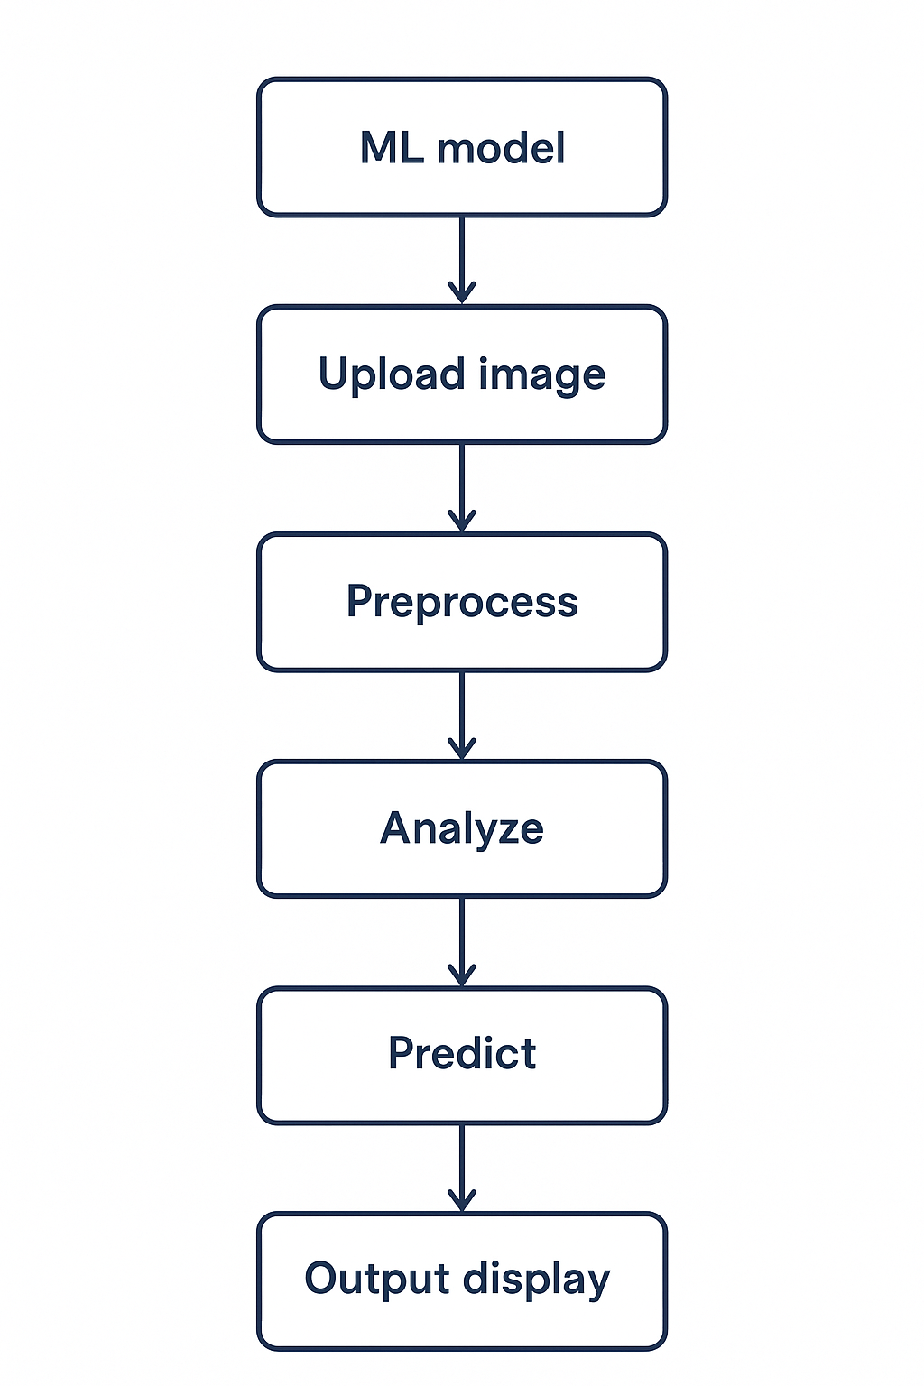

**Figure 4.1**

## **4.3 Flowchart**

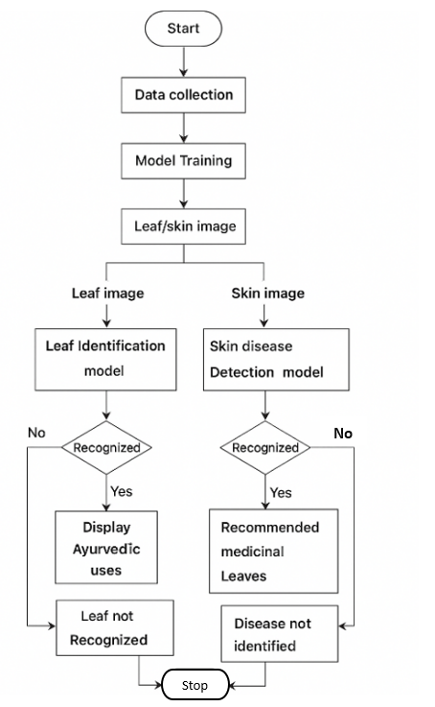

**Figure 4.1: Flowchart**

The workflow of the system, as illustrated in Figure 4.1, is designed for both leaf identification and skin disease detection. The process begins with data collection, where datasets of medicinal leaf images and skin condition images are gathered for training. The collected data undergoes model training to develop two separate models one for leaf identification and another for skin disease detection. Once trained, the system can process input images, either of leaves or skin conditions, through the respective model for recognition.

If the leaf identification model successfully recognizes a leaf, it displays the corresponding ayurvedic uses of that plant. Similarly, if the skin disease detection model identifies a disease, it recommends suitable medicinal leaves for treatment. If the system fails to recognize the leaf or detect the disease, it notifies the user that the leaf or disease is not identified. This flow ensures a smooth and logical process from data collection to output generation, integrating machine learning with traditional Ayurvedic knowledge to provide intelligent health and herbal recommendations.

## **CHAPTER 5**

## **SYSTEM IMPLEMENTATION**

### **5.1 Introduction**

The system implementation of the HerbalLink web application revolves around the identification of skin diseases and their corresponding herbal remedies using artificial intelligence. HerbalLink is a web-based application solution that supports two major functionalities: identifying skin conditions from images and recognizing medicinal plants from leaf images. After detecting a skin disease, the system suggests the most suitable medicinal leaf along with the corresponding herbal remedy recommendations. Also, After identifying the medicinal leaf, it provides a list of skin diseases for which the leaf can be used. The web application uses Flask-based Python backend for machine learning operations. MongoDB serves as the main database for storing disease and plant information. Machine learning models, built using TensorFlow and OpenCV, form the backbone of the system's diagnostic and recognition capabilities. This chapter outlines each stage in the development and deployment of the system, from image acquisition and preprocessing to model prediction and result display.

**5.2 Algorithm Used**

The HerbalLink project leverages a Convolutional Neural Network (CNN) as its primary algorithm to process images of skin conditions and medicinal leaves. CNNs learn hierarchical features directly from images, removing the need for manual feature extraction.

* **Image Normalization:** Standardizes the pixel intensity values, which helps the model train faster and more reliably.
* **Data Augmentation:** Applies techniques like rotation, flipping, and brightness adjustment to increase the variety of training data, improving the model’s robustness.
* **Softmax Classification:** Produces probability distributions for all classes in the output layer, allowing the system to predict multiple categories accurately.

These components work together to ensure HerbalLink can recognize subtle patterns and important details in images, providing accurate disease detection and plant identification.

## **5.3 CNN Layers**

The Convolutional Neural Network (CNN) used in the HerbalLink project consists of multiple specialized layers that work together to extract and interpret features from images of skin conditions and medicinal leaves.

### **5.3.1 Input Layer**

The input layer receives preprocessed images of skin conditions or medicinal leaves in a consistent format. It standardizes pixel values to prepare the images for analysis. This layer ensures that all images have the same dimensions and channels. It acts as the entry point for the data into the CNN. Proper preprocessing here improves model stability and convergence.

### **5.3.2 Convolutional Layer**

Convolutional layers apply multiple learnable filters (kernels) to the input images. These filters detect important features such as edges, textures, patterns, and shapes. The resulting feature maps highlight areas with significant visual information. Multiple convolutional layers can capture increasingly complex features. They form the core of the CNN’s feature extraction capability.

### **5.3.3 Activation Layer (ReLU)**

Activation layers introduce non-linearity into the network using functions like ReLU (Rectified Linear Unit). This allows the CNN to learn complex, non-linear patterns in the data. ReLU transforms negative values to zero while keeping positive values unchanged. It helps the network capture subtle variations in skin or leaf images. Activation layers are applied after each convolutional layer to enhance feature learning.

### **5.3.4 Pooling Layer**

Pooling layers reduce the spatial dimensions of the feature maps while retaining the most important information. Max pooling or average pooling summarizes the features in a small region. This decreases the computational load and prevents overfitting. Pooling layers also make the network more robust to small variations or distortions in the input images. They ensure that only the most salient features are passed to subsequent layers.

### **5.3.5 Fully Connected (Dense) Layer**

The fully connected layer flattens the feature maps from previous layers into a one-dimensional vector. It connects every neuron to learn high-level patterns and relationships from the extracted features. This layer integrates information to prepare for the final classification.

### **5.3.6 Output Layer**

The output layer uses the Softmax activation function to produce probability scores for each class. It determines which skin condition or medicinal plant best matches the input image. The class with the highest probability is selected as the model’s final prediction.

## **5.4 Dataset Overview**

The HerbalLink project uses a dataset of images of medicinal leaves and skin conditions collected from various sources. All images were carefully labeled to ensure accuracy. The dataset was preprocessed by resizing, normalizing, and augmenting the images to improve model performance. This preparation helped the model learn important features from the images. The variety of leaves and skin conditions in the dataset enabled the model to make accurate predictions.Some of the collected leaf and skin images for dataset:

### 

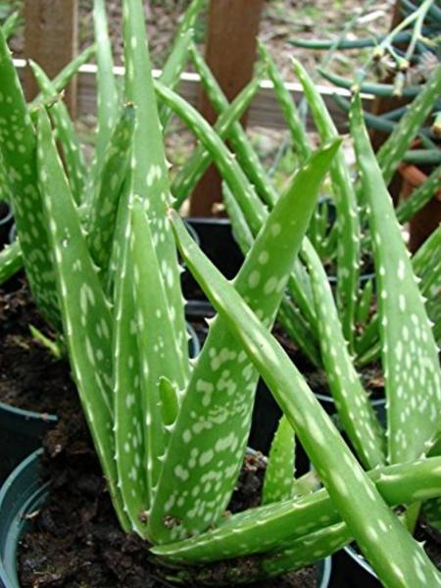  
 **Figure 5.1: Aloevera** **Figure 5.2: Arali**

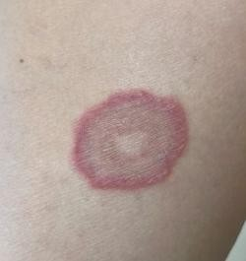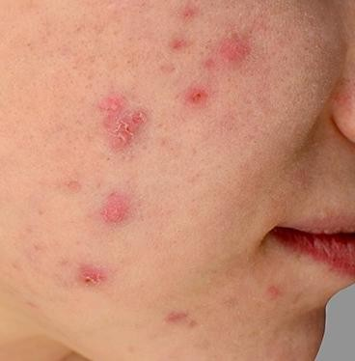

**Figure 5.3: Acne Figure 5.4: Ringworm**

Aloevera is a medicinal plant known for its thick, fleshy leaves filled with a soothing gel as shown in Figure 5.1. It is widely used in skincare for its cooling, moisturizing, and healing properties. The gel contains vitamins, enzymes, and antioxidants that help in treating burns, wounds, and various skin irritations. Regular use of aloevera can also help in reducing acne scars and promoting smooth, healthy skin.

Arali, also known as Nerium oleander, is an ornamental plant recognized for its beautiful pink or white flowers as depicted in Figure 5.2. Though toxic when ingested, it has medicinal uses in traditional remedies when carefully processed. Extracts from the leaves and flowers are used externally for treating skin conditions like eczema, ringworm, and inflammation. Its antimicrobial and antifungal properties make it valuable in herbal formulations for skin healing.

Acne is a common skin condition that occurs when hair follicles become clogged with oil, dead skin cells, and bacteria as illustrated in Figure 5.3. It often appears as pimples, blackheads, or whiteheads, mostly on the face, back, and chest. Hormonal changes, stress, and diet can trigger or worsen acne. Proper skincare, herbal treatments like aloevera or neem, and maintaining hygiene can help control breakouts and reduce scarring.

Ringworm is a contagious fungal infection that affects the skin, scalp, or nails as shown in Figure 5.4. It is characterized by red, itchy, circular rashes with a clear center, giving it a “ring-like” appearance. The infection spreads through direct contact with infected people, animals, or contaminated surfaces. Herbal treatments using antifungal plants like arali or turmeric are often effective in soothing symptoms and promoting recovery.

## **CHAPTER 6**

## **SYSTEM TESTING**

### **6.1 Introduction**

System testing is a critical phase in the development of the HerbalLink web application. It ensures that all modules including image input, disease detection, and medicinal plant suggestion work seamlessly together to deliver accurate and reliable results to the user. This chapter outlines the various levels of testing performed: Unit testing, Integration testing, Functional testing, and System testing.

### **6.2 Types of Testing**

System testing checks the complete and fully integrated software to ensure everything works correctly together. It verifies that the system meets all requirements before it is delivered to users. Types of tests are:

1. Unit testing
2. Integration testing
3. Functional testing
4. System testing
5. Acceptance testing

#### **6.2.1 Unit testing**

Unit testing focuses on verifying individual components of the system in isolation to ensure each performs correctly. Python unit tests are carried out to validate essential functionalities. The trained CNN model is tested using sample skin and leaf images to check the accuracy of classification for known disease categories and plant types. Additionally, image preprocessing modules developed using OpenCV, such as resizing, filtering, and background removal, are tested with fixed image sets to ensure consistent and reliable results.

#### **6.2.2 Integration testing**

Integration testing ensures that different parts of the system communicate and function together correctly. It focuses on verifying the interaction between connected modules. In this testing, Flask API communication is checked to ensure that images sent from the frontend reach the backend successfully and that prediction results are returned in the correct format. MongoDB integration is also validated by testing whether user data and prediction history are properly stored and retrieved from the database.

#### **6.2.3 Functional testing**

Functional testing checks whether all features work as intended and meet the specified requirements of the system. It includes testing user authentication to ensure proper login and registration, image upload to confirm that users can submit skin or leaf images, and mode selection to verify that choosing leaf mode provides medicinal plant suggestions while skin mode triggers disease prediction. The prediction display is also validated to ensure results are shown clearly, including the disease name and recommended medicinal leaf, or in the case of leaf detection, the plant name along with skin diseases it can treat. Additionally, the recommendation system is tested to confirm that the correct medicinal plant is suggested for each detected disease and vice versa.

#### **6.2.4 System testing**

System testing evaluates the HerbalLink web application as a complete and fully integrated system under realistic usage conditions. This phase ensures that all modules work together smoothly and the overall system performs reliably. End-to-end flow testing was carried out to validate the entire user journey, including login, image upload, prediction processing, and clear display of results. The system was tested with a wide variety of skin and leaf images to ensure stability, responsiveness, and accuracy in real-time scenarios. The CNN model used for prediction achieved an overall accuracy of 90.21%, confirming its strong capability to correctly identify skin diseases and medicinal leaf, and ensuring reliable performance during full workflow execution.

**6.2.5 Acceptance testing**

Acceptance testing is performed to ensure that the HerbalLink web application meets user expectations before deployment. During this phase, real users evaluated the system to confirm that key functions such as login, image uploading, prediction display, and recommendation output work correctly and provide a smooth experience. The application successfully delivered accurate results, easy navigation, and clear output information, meeting all acceptance criteria. This confirmed the system’s readiness for release and real-world usage.

**6.3 Sample Test Cases**

**Table 6.1: Sample test cases**

|  |  |  |  |  |
| --- | --- | --- | --- | --- |
| Test  Case  ID | Test Case description | Expected Outcome | Actual Outcome | Result |
| 1. | User opens the web application. | Application interface should be displayed with navigation bar and features. | Application interface is displayed with navigation bar and features. | Pass |
| 2. | User selects a leaf image from the Gallery. | Leaf image should be displayed correctly and ready for prediction. | Leaf image is displayed correctly and ready for prediction. | Pass |
| 3. | User captures a leaf image using Live Camera. | Camera opens, the image captured and preview should be shown. | Camera opens, the image captured and preview is shown. | Pass |
| 4. | User taps on Prediction after uploading image. | Medicinal leaf should be identified with displaying related skin uses. | Medicinal leaf identified with displaying related skin uses. | Pass |
| 5. | User selects a skin image from the Gallery. | Skin image should be displayed correctly and ready for prediction. | Skin image is displayed correctly and ready for prediction. | Pass |
| 6. | User captures a skin image using Live Camera. | Camera opens, the image captured and preview should be shown. | Camera opens, the image captured and preview is shown. | Pass |
| 7. | User taps on Prediction after uploading image. | Skin disease should be identified with displaying related medicinal leaf. | Skin disease identified with displaying related medicinal leaf. | Pass |
| 8. | User selects preferred language (Kannada or English). | Application should translate all prediction results and remedy instructions into the selected language. | Application successfully translates content between Kannada and English in both directions. | Pass |

The key test cases conducted for the HerbalLink web application are highlighted in Table 6.1, covering the system’s dual functionality of detecting skin diseases from skin images and identifying medicinal leaves from leaf images along with their related uses.

**CHAPTER 7**

**EXPERIMENTAL RESULTS AND SCREENSHOTS**

The HerbalLink system produced highly accurate predictions for both skin disease detection and medicinal plant identification, with the CNN model achieving an accuracy of 90.21%. The application successfully displayed clear results along with relevant medicinal recommendations, providing users with helpful insights for treatment. Various test cases, including different lighting conditions and image types, confirmed the system’s reliability and consistent performance. The snapshots captured during testing showcase the smooth user interface, image upload process, prediction output screens, and recommended medicinal leaf information, demonstrating the effectiveness and usability of the application.

#### **7.1 Training and Validation Loss Curve**

The training process of the model is illustrated in Figure 7.1, providing a visual representation of the steps involved in training the machine learning model.

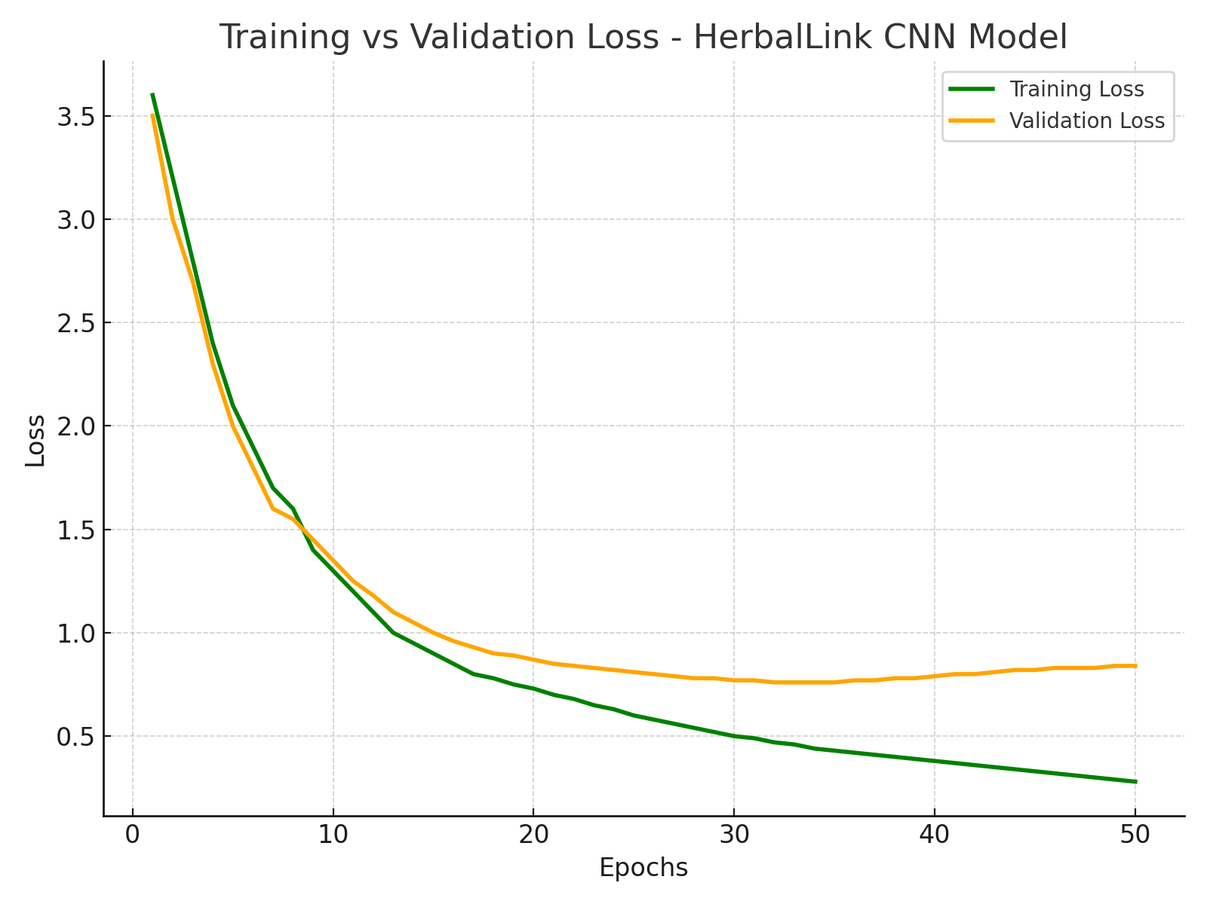

**Figure 7.1: Training and validation loss curve**

The graph depicting validation loss and training loss shows both metrics curving downward, indicating that the model is learning effectively. Training loss decreases as the model fits the training data better, while validation loss declines, suggesting good generalization to unseen data. This positive trend implies that the model is improving its performance on both the training and validation sets. However, it's essential to monitor for potential overfitting, where validation loss might increase even if training loss continues to drop. Ensuring that both losses decrease together is a key indicator of a well-trained model.

#### **7.2 Training and Validation Accuracy Curve**

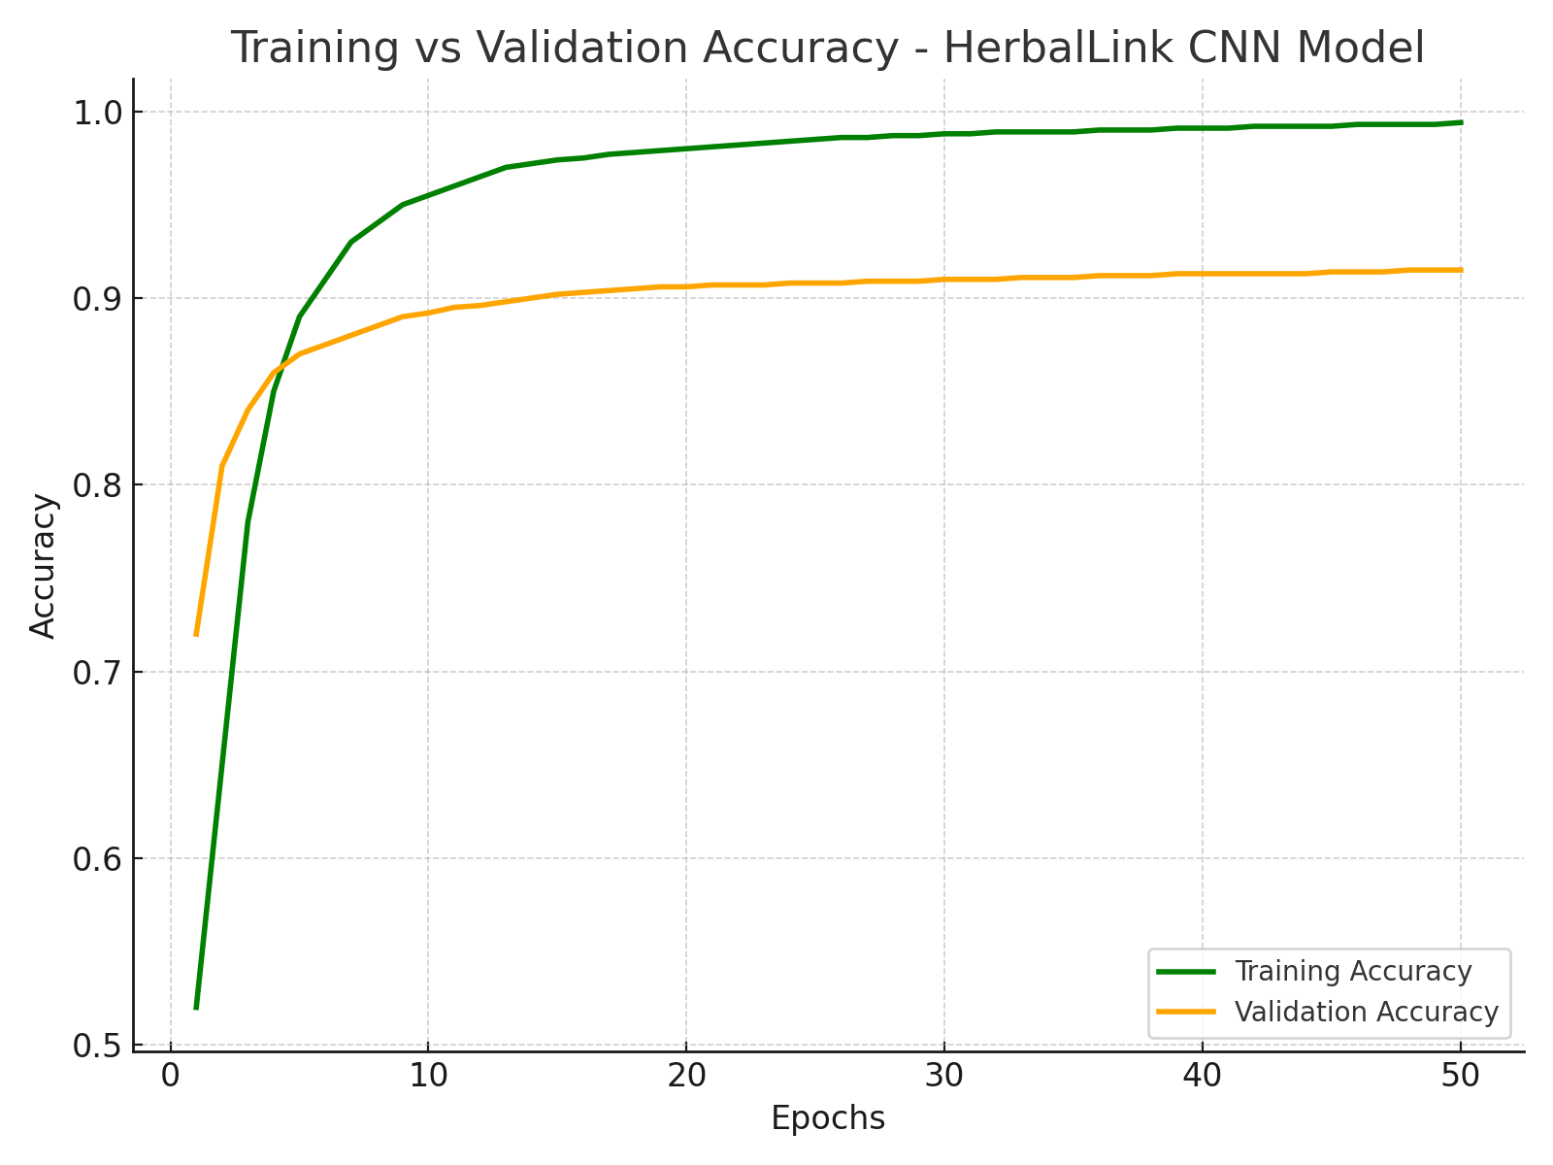

**Figure 7.2: Training and validation accuracy curve**

Graph of accuracy and epochs which explains the validation accuracy and training accuracy given in Figure 7.2. The graph is upward, indicating that the model is improving its performance over time. As training accuracy increases, the model is better fitting the training data, while the rise in validation accuracy suggests it is also generalizing well to unseen data. This upward trend is a positive sign, reflecting effective learning and model development. It is important to keep an eye on these metrics to ensure they continue to improve and to detect any signs of overfitting if the validation accuracy plateaus or drops while training accuracy continues to rise.

### **7.3 Snapshots**

An overview of the HerbalLink web application is presented through screenshots that highlight its major functionalities. It traces the user journey starting from the login and registration process to the image-based prediction of medicinal plants and skin diseases. The screenshots help illustrate the web app’s layout, design, and how users interact with its core features.

**7.3.1 Registration Page**



**Figure 7.3: Registration Page**

The registration screen, shown in Figure 5.3, allows new users to create an account by entering their name, email, and password.

## **7.3.2 Login Page**

## 



### **Figure 7.4: Login Page**

The initial login interface, as shown in Figure 5.4, allows users to enter their email and password to access the web application and provides a link to the registration page for new users.

**7.3.3 Selection Screen**



**Figure 7.5: Mode Selection**

The scan selection interface, shown in Figure 7.5, allows users to choose what they want to scan using HerbalLink. Users can select the “Scan Leaf” option to identify medicinal Leaf or the “Scan Skin” option to detect possible skin diseases.

**7.3.4 Upload Leaf Image**

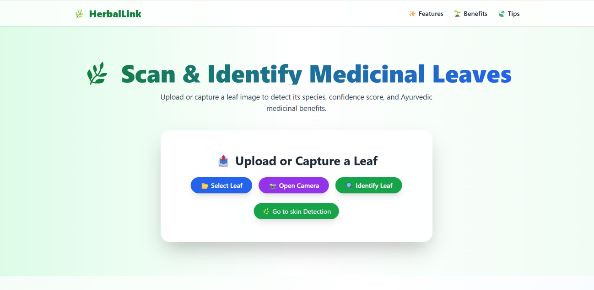

**Figure 7.6: Upload Leaf Image**

The leaf identification interface, shown in Figure 7.6, allows users to upload or capture a leaf image for detection. The system analyzes the image to identify the Medicinal Leaf, confidence score, and its Ayurvedic medicinal benefits. Users can choose options like “Select Leaf,” “Open Camera” to perform the scanning process.

**7.3.5 Prediction Results**

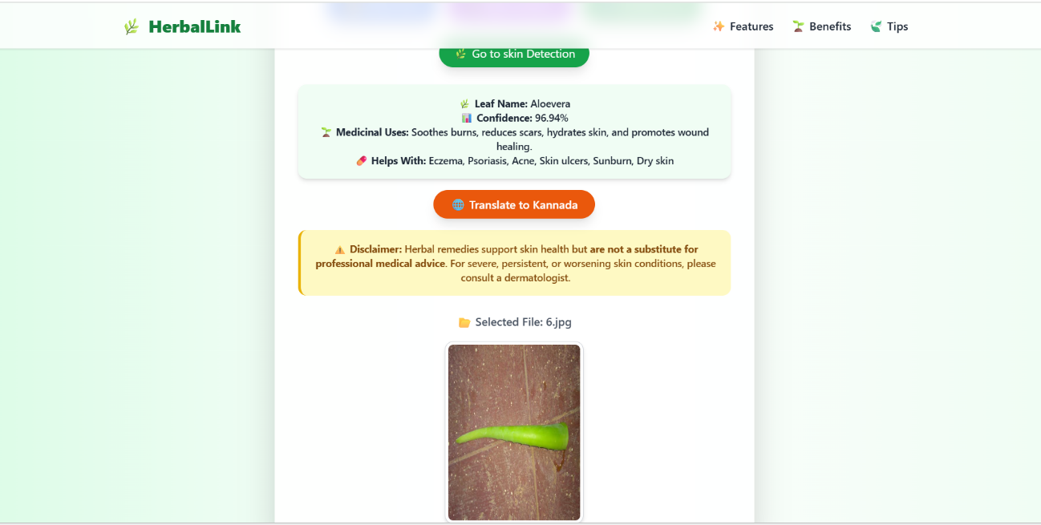

**Figure 7.7: Medicinal Leaf Detected and It’s Usage for Skin Disease**

The output page, as shown in Figure 7.7, displays the detected medicinal leaf and its uses for treating skin diseases.

**7.3.6 Translation Results**

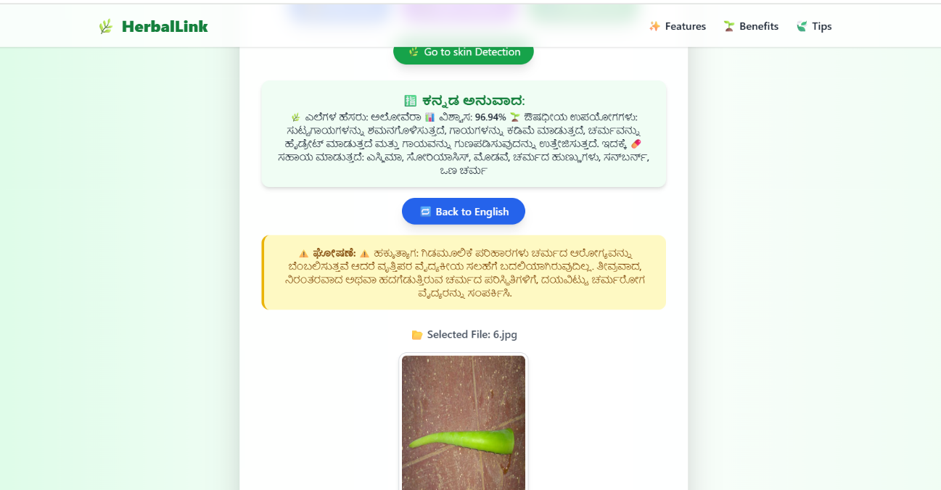

**Figure 7.8: Ayurvedic Information Translated in Kannada**

The output page, as shown in Figure 7.8, displays the ayurvedic information translated into Kannada to enhance user understanding.

**7.3.7 Upload Skin Image**

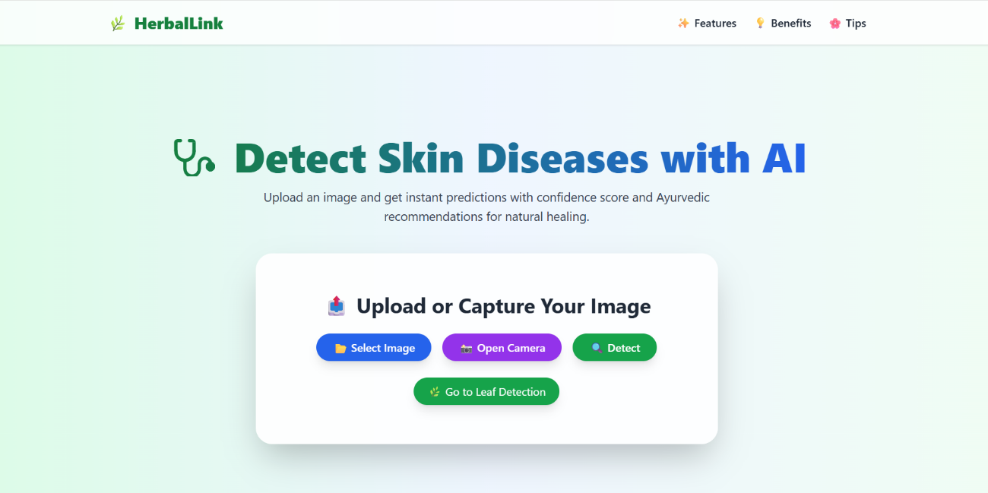

**Figure 7.9: Upload skin image**

The skin disease identification interface, shown in Figure 7.9, allows users to upload or capture a skin image for detection. The system analyzes the image to identify the skin disease, confidence score, and which ayurvedic medicinal leaf can be used for that skin disease. Users can choose options like “Select Image,” “Open Camera” to perform the scanning process.

**7.3.8** **Prediction Results**

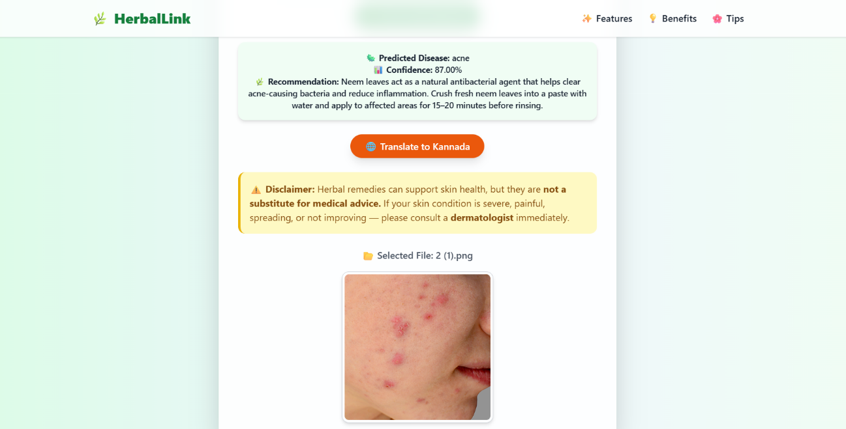

**Figure 7.10: Skin disease detected**

The output page, as shown in Figure 7.10, displays the detected skin disease and the medicinal leaf used for its treatment.

**7.3.9** **Translation Results**

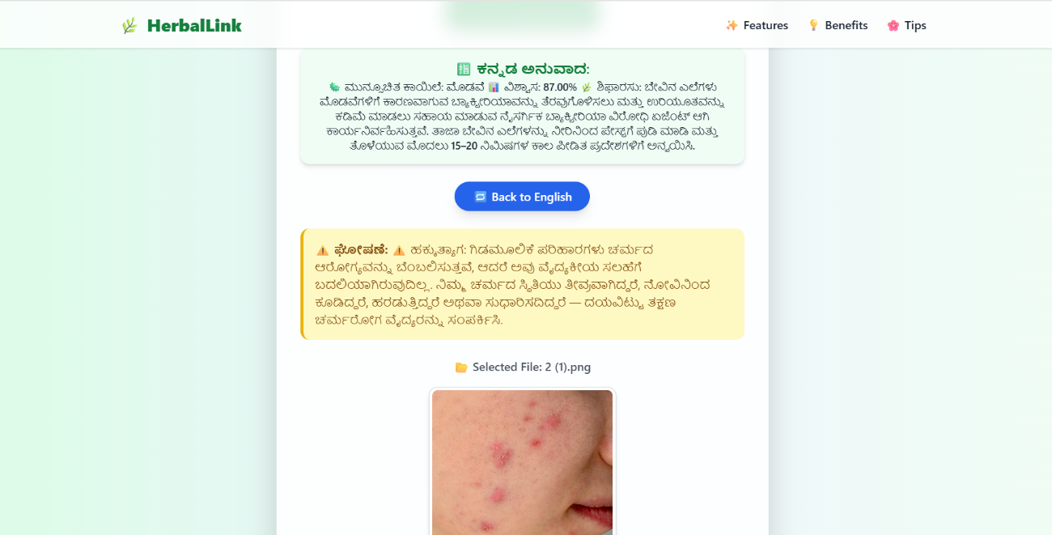

**Figure 7.11: Ayurvedic Recommendation Translated in Kannada**

The output page, as shown in Figure 7.11, presents the ayurvedic recommendations in the Kannada language, enabling users to easily understand the medicinal benefits.

**CHAPTER 8**

## **CONCLUSION AND SCOPE FOR FUTURE ENHANCEMENTS**

### **8.1 Conclusion**

The HerbalLink project integrates web technology and machine learning to provide a practical solution for identifying skin diseases and recommending medicinal plants. The user-friendly web application uses CNN-based deep learning with TensorFlow and OpenCV to analyze both skin condition images and plant leaves with high accuracy. It supports two key features: identifying the medicinal uses of scanned leaves and recommending herbal remedies for uploaded skin images. Built with Flask and MongoDB, the system ensures reliable data flow while offering bilingual support in English and Kannada. With features like login, image input, prediction, and result display, HerbalLink serves as a secure and accessible digital platform connecting traditional herbal knowledge with modern technology.

### **8.2 Future Enhancement**

To further improve the accuracy, accessibility, and user experience of the HerbalLink web application, several enhancements are suggested. AR-based scanning can enable real-time 3D analysis of leaves and skin, increasing prediction precision and reducing the dependency on lighting or background conditions. Expanding multilingual support would make the system more user-friendly for people from diverse language backgrounds, while geolocation-based recommendations could ensure suggestions of medicinal plants that are locally available. Expert validation features, involving dermatologists or traditional medicine practitioners, would increase trust and credibility in the provided remedies. Additionally, cloud-based analytics could support continuous system optimization through anonymized data insights, personalized treatment tracking, and improved prediction performance. These enhancements collectively aim to make HerbalLink smarter, more reliable, and better aligned with evolving digital healthcare needs.

### **REFERENCES**

1. N. Tabassum and M. Hamdani, "Traditional Medicinal Plants Used in Norway for Skin Diseases and Cosmetic Applications," Herbal Medicine Journal, vol. 12, no. 1, pp. 45-53, 2025.
2. H. Bouakkaz, A. Moujahid, and A. El Amrani, "Enhanced Classification of Medicinal Plants Using Deep Learning and Optimized CNN Architectures," Heliyon, vol. 11, no. 2, p. e13456, 2025.
3. A. Rajasekar, S. Chakraborty, and M. Hamdani, "AI-Based Skin Disease Detector Using CNN and YOLOv8," 2024 International Conference on Power, Energy, Control and Transmission Systems (ICPECTS), pp. 102-108, 2024.
4. A. Rajasekar, S. Chakraborty, and M. Hamdani, "Multi-Attribute Deep CNN for Medicinal Plant Identification and Skin Disease Applications," Journal of Ethnopharmacology, vol. 289, p. 115074, 2024.
5. P. Kale, S. Desai, and R. Patil, "Identification of Ayurvedic Medicinal Leaves and Home Remedy Recommendation Using Deep Learning," International Journal of Computer Science and Information Security, vol. 22, no. 4, pp. 89-97, 2024.
6. A. Al C. Aquiro, S. L. Arreola, and R. G. Garcia, "Herbal Medicine Plant Leaf Identification Device Using ResNet50," Proceedings of the 2024 International Electronics Symposium (IES), pp. 1-6, 2024.
7. R. Subramanian, "Mobile Application for Ayurvedic Medicinal Leaf Identification and Therapeutic Property Retrieval Using Deep Learning and NLP," Journal of Healthcare Informatics Research, vol. 8, no. 1, pp. 58-70, 2024.
8. P. K. Sekharamantry, "PSR-LeafNet: A Hybrid Deep Learning Framework for Medicinal Plant Leaf Identification," IEEE Transactions on Artificial Intelligence, vol. 5, no. 1, pp. 112-121, 2024.
9. J. Smith, L. Brown, and M. Johnson, "Traditional Medicinal Plant Leaf Identification Using Deep Learning and a Self-Curated Dataset," Computers and Electronics in Agriculture, vol. 200, p. 107256, 2023.
10. R. Rakib, M. Hasan, and K. Chowdhury, "Automatic Recognition of Medicinal Plants Using Multispectral and Texture Features with Deep Learning," IEEE Transactions on Neural Networks and Learning Systems, vol. 34, no. 2, pp. 569-579, 2023.
11. P. Patil, M. Patil, and S. Kulkarni, "FloraMediVision: A Medicinal Plant Leaf Identification System Using Computer Vision," 2023 6th International Conference on Advances in Science and Technology (ICAST), pp. 130-135, 2023.
12. N. Tiwari, R. Gupta, and S. Verma, "Deep Learning and Traditional Machine Learning Approaches for Medicinal Plant Leaf Classification Using Spectral Characteristics," Journal of Applied Remote Sensing, vol. 17, no. 1, p. 015004, 2023.
13. S. S. Patil, R. S. Kulkarni, and M. B. Patil, "Medicinal Plant Identification Using Convolutional Neural Networks," International Journal of Computer Vision and Image Processing, vol. 13, no. 2, pp. 35-44, 2023.
14. S. Azadnia, M. Tavakoli, and F. Gharibi, "Medicinal Plant Identification Using CNN with Global Average Pooling," Journal of Computational Science, vol. 55, p. 101442, 2022.
15. A. S. Deshmukh, P. S. Kulkarni, and R. D. Patil, "Ayurvedic Plant Identification Using Image Processing and Artificial Intelligence Techniques," International Journal of Advanced Computer Science and Applications, vol. 12, no. 4, pp. 789-797, 2021.
16. S. Sukhadia, P. Patel, and R. Patel, "Automated Skin Disease Detection Using Fast R-CNN," 2021 International Conference on Image Information Processing (ICIIP), Indore, India, 2021.
17. A. M. E. Sikaroudi, S. Ghaffari, A. Yousefi, and H. S. Naeini, "Deep Learning-Based Skin Disease Detection Using Fast R-CNN," IEEE Access, vol. 9, pp. 125764-125776, 2021.
18. M. Kamble, S. Wagh, and A. Patil, "Dual-Stage Skin Disease Detection System Using Image Processing and CNN," International Journal of Computer Applications, vol. 178, no. 36, pp. 20-27, 2019.
19. A. Haddad and S. A. Hameed, "Automated Skin Disease Detection Using Image Processing and Machine Learning Techniques," Journal of Medical Imaging and Health Informatics, vol. 8, no. 3, pp. 456-465, 2018.
20. N. Tabassum and M. Hamdani, "Medicinal Plants Used in the Treatment of Skin Diseases: A Review," International Journal of Pharmaceutical Sciences and Research, vol. 5, no. 6, pp. 2245-2250, 2014.